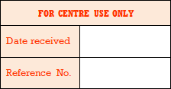

Internal appeals form
Appeal against an internal assessment decision
Name of appellant |  | Candidate name  if different to appellant
Awarding body |  | Unit code
Subject |  | Unit title
Please state the grounds for your appeal below

If necessary continue on an additional page if this form is being completed electronically or overleaf if hard copy being completed
Appellant declaration
By signing here, I am confirming I understand the purpose of the appeal will be to decide whether the process used for the internal assessment conformed to the published requirements of the awarding body’s specification and subject-specific associated documents. I also understand the appeal may only be made against the marking/assessment process - not against the mark submitted by the centre for moderation by the awarding body.

Appellant signature: Date of signature:
This form must be signed, dated and returned to the exams officer on behalf of the head of centre to the timescale indicated in the relevant appeals procedure

